ProjectDesignPhase-II

DataFlowDiagram&UserStories

|  |  |
| --- | --- |
| Date | 03 October2022 |
| TeamID | PNT2022TMID01551 |
| ProjectName | Project-ANovelMethodForHandwrittenDigitRecognitionSystem |
| MaximumMarks | 4 Marks |

# DataFlowDiagrams:

A Data Flow Diagram (DFD) is a traditional visual representation of the information flows within a system. A neat and clear DFD can depict the rightamount of the system requirement graphically. It shows how data enters and leaves the system, what changes the information, and where data isstored.

Example:DFDLevel0(IndustryStandard)

# Example:[(Simplified](https://developer.ibm.com/patterns/visualize-unstructured-text/))FLOW

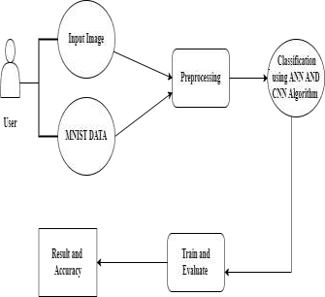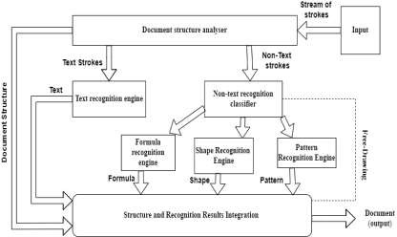

**UserStories**

Usethebelowtemplatetolistalltheuserstoriesfortheproduct.

|  |  |  |  |  |  |  |
| --- | --- | --- | --- | --- | --- | --- |
| **UserType** | **Functional**  **Requirement(Epic)** | **UserStoryNumber** | **UserStory/Task** | **Acceptancecriteria** | **Priority** | **Release** |
| Customer(Mobileuser) | Home | USN-1 | Asauser,Icanviewtheguideandawarenesstousethis application. | I can view the awarenesstousethisapplicationanditslimitations. | Low | Sprint-1 |
|  |  | USN-2 | As a user, I’m allowed to view the guidedvideotousetheinterfaceofthis application. | I can gain knowledge touse this application by apracticalmethod. | Low | Sprint-1 |
|  |  | USN-3 | Asauser,Icanreadtheinstructionstousethisapplication. | Icanreadinstructionsalsoto use it in a user-friendlymethod. | Low | Sprint-2 |
|  | Recognize | USN-4 | Asauser, InthispredictionpageIgettochoosetheimage. | I can choose the imagefromourlocalsystemandpredicttheoutput. | High | Sprint-2 |
|  | Predict | USN-6 | Asauser,I’mAllowedtouploadandchoosethe imagetobeuploaded | I can upload and choosetheimagefromthesystemstorage and also in anyvirtualstorage. | Medium | Sprint-3 |
|  |  | USN-7 | Asauser,Iwill trainandtestthe inputto getthemaximumaccuracyofoutput. | Icanabletotrainandtesttheapplicationuntilitgetsmaximum accuracy of theresult. | High | Sprint-4 |
|  |  | USN-8 | Asauser, Ican accesstheMNISTdataset | IcanaccesstheMNISTdata set to produce theaccurateresult. | Medium | Sprint-3 |
| Customer(Webuser) | Home | USN-9 | Asauser,Icanviewtheguideto usethewebapp. | Icanviewtheawarenessof this application and itslimitations. | Low | Sprint-1 |

|  |  |  |  |  |  |  |
| --- | --- | --- | --- | --- | --- | --- |
| **UserType** | **FunctionalRequirement(Epic)** | **UserStoryNumber** | **UserStory/Task** | **Acceptancecriteria** | **Priority** | **Release** |
| Customer(Mobileuser) | Home | USN-1 | Asauser,Icanviewtheguideandawarenesstousethis application. | I can view the awarenesstousethisapplicationanditslimitations. | Low | Sprint-1 |
|  |  | USN-2 | As a user, I’m allowed to view the guidedvideotousetheinterfaceofthis application. | I can gain knowledge touse this application by apracticalmethod. | Low | Sprint-1 |
|  |  | USN-3 | Asauser,Icanreadtheinstructionstousethisapplication. | Icanreadinstructionsalsoto use it in a user-friendlymethod. | Low | Sprint-2 |
|  | Recognize | USN-10 | Asauser,Ican usethewebapplicationvirtuallyanywhere. | Icanusetheapplicationportablyanywhere. | High | Sprint-1 |
|  |  | USN-11 | Asit isan opensource,canuse itcostfreely. | I can use it without anypaymenttobepaidforittoaccess. | Medium | Sprint-2 |
|  |  | USN-12 | Asitisawebapplication,itisinstallation free | Icanuseitwithouttheinstallation of theapplication or anysoftware. | Medium | Sprint-4 |
|  | Predict | USN-13 | Asauser,I’mAllowedtouploadandchoosethe imagetobeuploaded | I can upload and choosetheimagefromthesystemstorage and also in anyvirtualstorage. | Medium | Sprint-3 |